1. Run the RAP tool as an admin
2. Enter the computer name and press enter

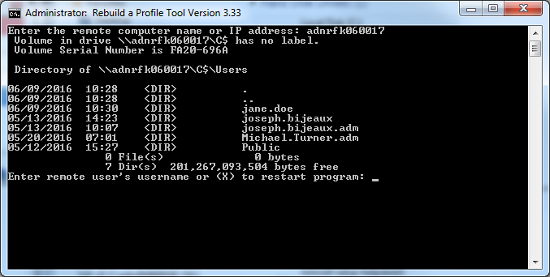

1. Check if the last name is in all caps
2. Enter the user name of the currently logged in user and press enter  
   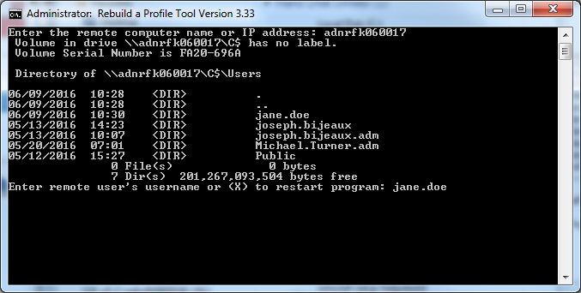
3. Press 'Y' to rebuild the profile or 'N' to restart the program.
   1. Use your best judgment. If it's over 5000000 bytes, the profile is probably corrupt, especially if the last name is in all caps.  
      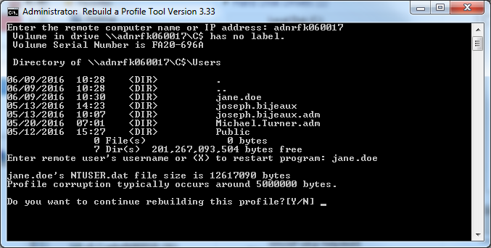
4. The tool will copy a backup tool (called 'Backup.bat') to the user's desktop.  
   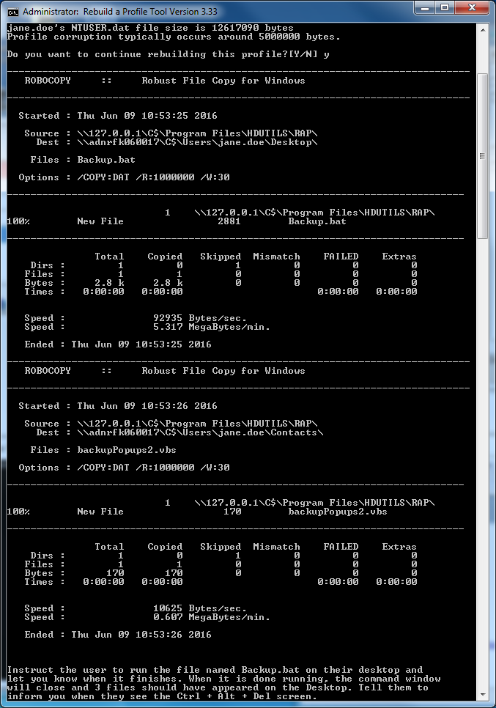
   1. Tell them to run it.
   2. Press 'No' on the prompt for a green shutdown
   3. Tell them to tell you when it gets to Ctrl + Alt + Del and do not log on
5. Press enter to copy a file to your computer that stores the user's SID  
   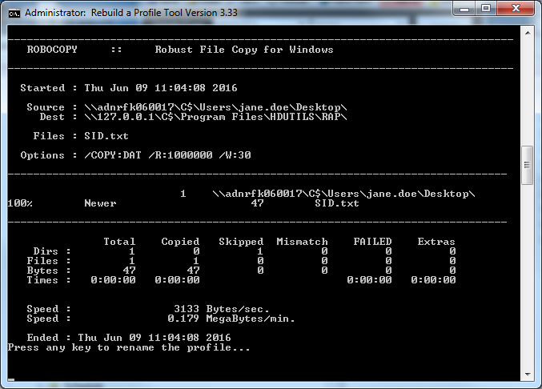
6. Press enter to rename the profile
   1. If it says 'Access Denied.':
      1. Press the 'Pause' button (just above the 'Page Up' button)
      2. Restart the computer from FixPack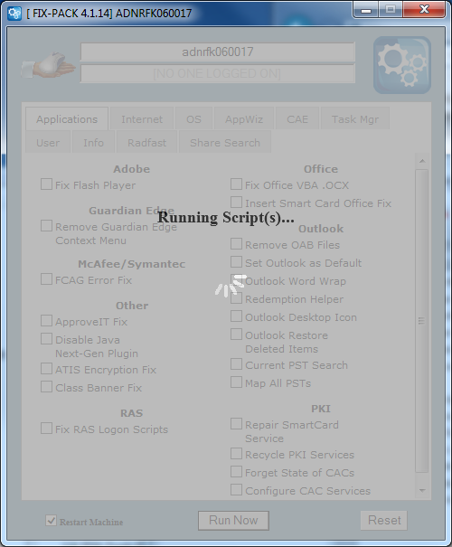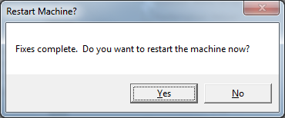
      3. Ping the computer continuously until you get a reply  
         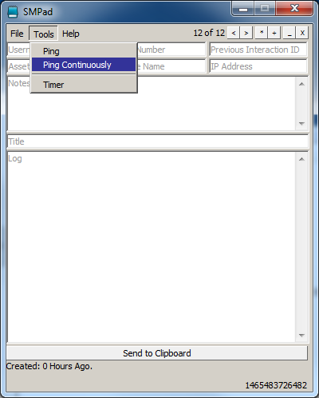  
         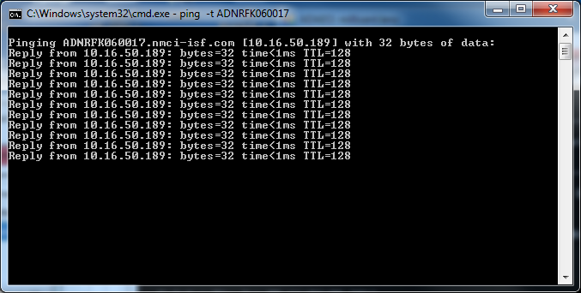
      4. Go back to the tool and press enter to rename the profile
      5. The tool will attempt to rename the profile until it is successful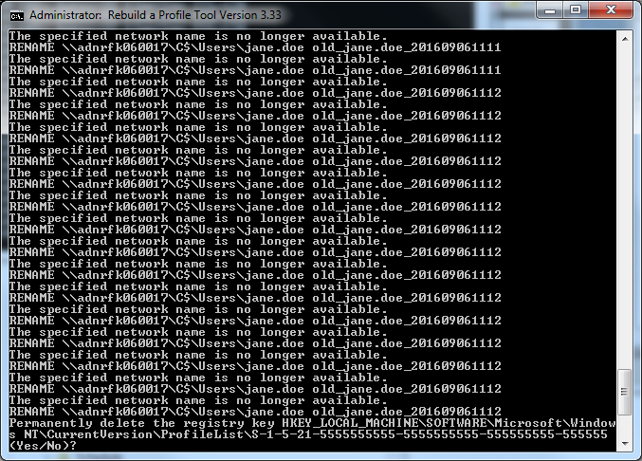
7. After the profile is renamed, the tool will remove the user's profile's registry key remotely. Press 'Y' then enter to allow it to do so.
8. 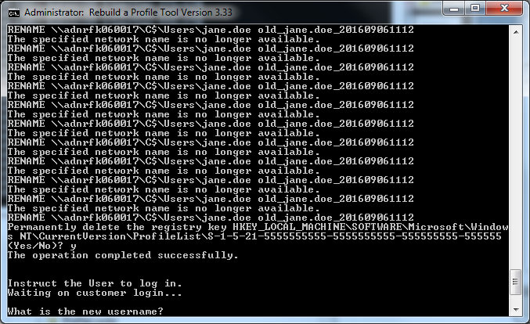
   1. If it cannot delete the key remotely, open the registry and remove it manually.
9. Tell the user to login after it says it has successfully deleted.

**\*NOTE\*** It will prompt you for the username again. Occasionally the user will have a name change and their email doesn't match the profile name. If this is the case, put the user's current email user ID in here, otherwise just press enter. EXAMPLE:

jane.smith used to be jane.doe so here we would put jane.smith because that is what the computer will log her in as. If the name has not changed, just press enter.

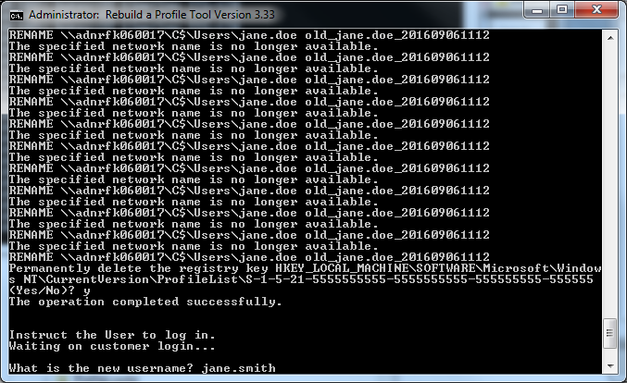

1. A block of text will be put on the clipboard. Paste it in your ticket before continuing.  
   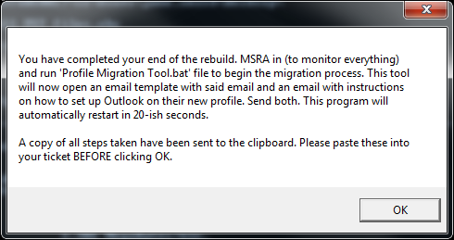  
   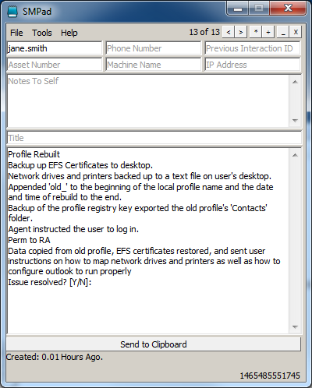
2. Two emails will pop up for you to send to the customer. They contain instructions for the customer on how to remap drives and printers. Send these to the user.
3. The tool will launch a remote assist session.
4. Once you have control, start the program called 'Profile Migration Tool.bat'
   1. About halfway through, it will pause and prompt you to import a registry key. These are the keys for the pinned icons available on the Taskbar and Start Menu.
   2. **BEFORE** clicking yes to import, check the user's desktop for a file named 'File Encryption Certificate'. If it is present, open it and import it. MAKE SURE TO MARK THE KEY AS EXPORTABLE!!! There is no password.
5. Once it says the import was successful, click yes on the prompt to import the registry keys.
6. The tool will continue to copy over the remaining data. Once it is complete, it will map all the PSTs. After that is complete, the tool will exit and delete the extraneous files related to the tool.